Lab 4
SQL Select Command/ Aggregate Functions/Subqueries

The general syntax for SELECT statement is-

SELECT [DISTINCT | ALL]
{* | [columnExpression [AS newName]] [,...] }
FROM TableName [alias] [, ...]
[WHERE condition]
[GROUP BY columnList]
[HAVING condition]
[ORDER BY columnList]
[LIMIT row_count]

In this case, only SELECT and FROM are must for this expression. All others are optional. Order of the clauses cannot be changed.

FROM Specifies table(s) to be used.
WHERE Filters rows.
GROUP BY Forms groups of rows with same column value.
HAVING Filters groups subject to some condition.
SELECT Specifies which columns are to appear in output.
ORDER BY Specifies the order of the output

Demonstration

Run the script hr_schema.sql. Then try to follow the steps provided below one by one and see the results.

Use of DISTINCT
DISTINCT is used to eliminate repeating elements.

- SELECT location_id FROM departments;
- SELECT DISTINCT location_id FROM departments;

Take a look at the difference between them.

Calculated Fields

You can make numerical calculations on related columns of a table also. In this case, we will divide the salary of employees who have department number 5.

- SELECT employee_id, salary as monthly_salary, (salary/30) as salary_per_day
FROM employees ;

Set Membership

- SELECT first_name, last_name
FROM employees
WHERE salary IN (17000, 24000);

This finds out the first and last name of those who has salary exactly 17000 or 24000. Similarly the following statement negates it.
- SELECT first_name, last_name
FROM employees
WHERE salary NOT IN (17000, 24000);

Single Column Ordering
This time we will use ORDER BY clause. It is used to represent data in the tables in some particular (and desired) order.
- SELECT first_name, last_name, salary
FROM employees
ORDER BY salary;
- SELECT first_name, last_name, salary
FROM employees
ORDER BY salary desc;
Which one is by default- ascending or descending?
Multiple Columns Ordering

When you are using multiple columns in ORDER BY clause, please be careful. Because, sometimes it is difficult to see the difference in actual results.
- SELECT first_name, last_name, salary, department_id
FROM employees
ORDER BY salary, department_id;

- SELECT first_name, last_name, salary, department_id
FROM employees
ORDER BY salary, department_id desc;

Patterns in SQL
The LIKE operator is a logical operator that tests whether a string contains a specified pattern or not.
MySQL provides two wildcard characters for constructing patterns: percentage % and underscore
_ .
• The percentage ( % ) wildcard matches any string of zero or more characters.
• The underscore ( _ ) wildcard matches any single character at its position

The formation of % operator:
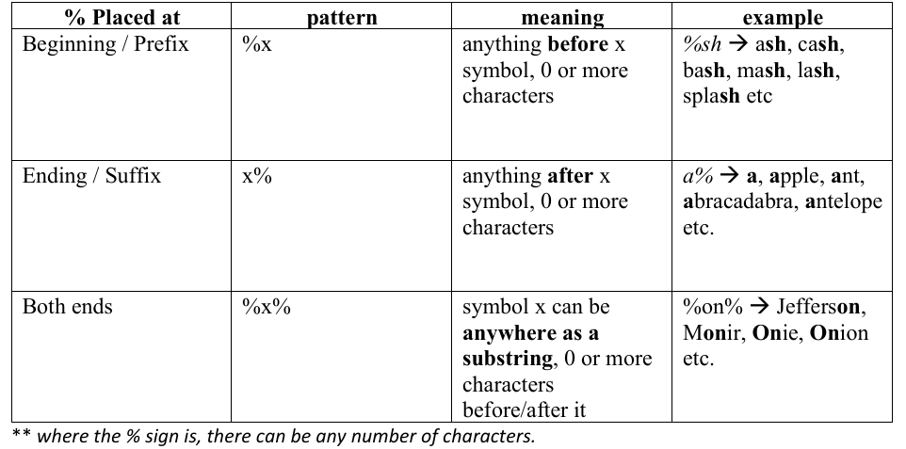

Example:
%on% → Jefferson,
Monir, Onie, Onion
etc.
o Find employees’ employeeId, , firstName whose first names contains the literal string ‘in’
SELECT employee_id, first_Name
FROM employees
WHERE first_Name LIKE '%in%';

- Find all employees employeeId, , firstName whose first names ends with the literal string ‘el’

SELECT employee_id, first_Name
FROM employees
WHERE first_name LIKE '%el';

The formation of _ (underscore) operator:
o Must match both position and length.
o Must be filled up by a single symbol where the underscore is (same as the fill in the gaps
) 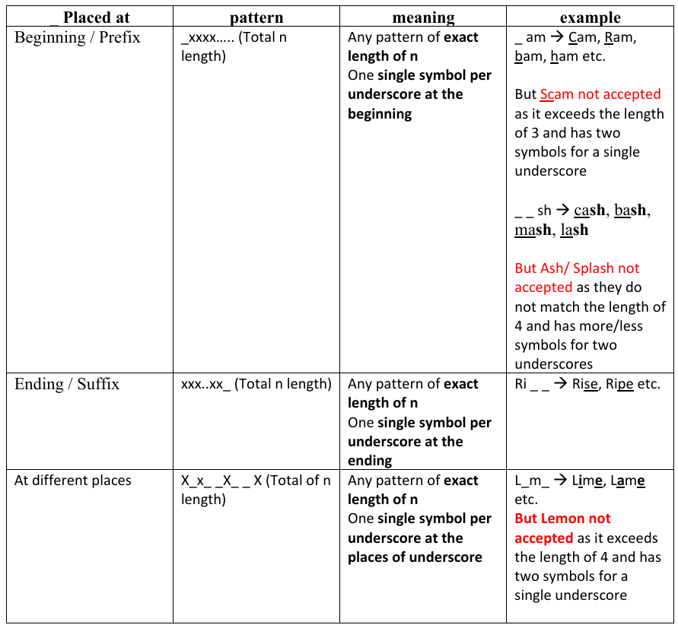

Example:
To find employees whose first names start with the letter T_m (eg. Tim. Tom etc), end with the letter m, and contain any single character between.
SELECT employeeNumber, lastName, firstName
FROM employees
WHERE firstname LIKE 'T_m';
Important note on % and _
• % → position must match but length doesn’t matter
• _ → position and length must match

Aggregate Functions
An aggregate function performs a calculation on multiple values and returns a single value.
Most commonly used aggregate functions are
• AVG () calculates the average of a set of values.
• COUNT () counts rows in a specified table or view.
• MIN () gets the minimum value in a set of values.
• MAX () gets the maximum value in a set of values.
• SUM () calculates the sum of values.
Each operates on a single column of a table and returns a single value.
COUNT, MIN, and MAX apply to numeric and non-numeric fields, but SUM and AVG may be used on numeric fields only.
Apart from COUNT(*), each function eliminates nulls first and operates only on remaining non-null values.
COUNT(*) counts all rows of a column, regardless of whether nulls or duplicate values occur.
Can use DISTINCT before column name to eliminate duplicates.
DISTINCT has no effect with MIN/MAX, but may have with SUM/AVG.
Aggregate functions can be used only in SELECT list and in HAVING clause.

- SELECT salary FROM employees;

- SELECT MAX(salary) FROM employees;

- SELECT MIN(salary) FROM employees;

- SELECT SUM(salary) FROM employees;

- SELECT AVG(salary) FROM employees;

- SELECT COUNT(*) , COUNT(manager_id), COUNT(ALL manager_id), COUNT(DISTINCT manager_id) FROM departments;

- SELECT COUNT(*), COUNT(manager_id), COUNT(ALL manager_id), COUNT(DISTINCT manager_id) FROM employees;

An important thing to note here is that ALL doesn't cause an aggregate function to consider NULL values.

GROUP BY:

The GROUP BY clause groups a set of rows into a set of summary rows by values of columns or expressions. The GROUP BY clause returns one row for each group. In other words, it reduces the number of rows in the result set.

The MySQL GROUP BY clause is used in a SELECT statement to collect data across multiple records and group the results by one or more columns.

The GROUP BY statement is often used with aggregate functions (COUNT(), MAX(), MIN(), SUM(), AVG()) to group the result-set by one or more columns.

GROUP BY is by default inherits DISTINCT () [ MySQL commands to find only the non-duplicate values] and doesn’t return any NULL values.

Syntax:

SELECT c1, c2,..., cn,aggregate_function(ci)
FROM table
WHERE some_conditions
GROUP BY c1, c2,…,cn;

- Count employees per department.

SELECT department_id ,COUNT(employee_id)
FROM employees
GROUP BY department_id;

While producing summary results using the GROUP BY clause, you can filter records from the table based on a WHERE clause.

- Count employees per department who earns more than 10000

SELECT department_id ,COUNT(employee_id)
FROM employees
WHERE salary>10000
GROUP BY department_id;

HAVING:

The HAVING clause is used in the SELECT statement to specify filter conditions for a group of rows or aggregates.

The HAVING clause is often used with the GROUP BY clause to filter groups based on a specified condition.

The HAVING clause was added to SQL because the WHERE keyword cannot be used with aggregate functions.

Syntax:

SELECT select_list
FROM table_name
WHERE search_condition
GROUP BY group_by_expression
HAVING group_condition_or_aggrgate_functions;

Example:

Q. Find those employees from each department whose salary is greater than his/her department’s average salary.

Ans:

SELECT first_name, dept_id, AVG (salary)
FROM employees
GROUP BY dept_id

***The query as written will not work correctly because of the inclusion of first_name in the SELECT clause without it being part of the GROUP BY clause or an aggregate function.

Points to remember:
■ HAVING can take conditions on aggregate functions.
■ WHERE can all other conditions.

Q. Find those departments that have more than 6 employees.

SELECT department_id, COUNT(employee_id)
FROM employees
GROUP BY department_id
HAVING COUNT(employee_id)>6;

A HAVING condition can refer only to an expression in the SELECT list, or to an expression involving an aggregate function. If you specify an expression in the HAVING clause that isn't in the SELECT list, or that isn't an aggregate expression, you will get an error.

For example:

SELECT department_id, COUNT(employee_id)
FROM employees
GROUP BY department_id
HAVING hire_date>1987-06-17;

However, you can use an aggregate expression in the HAVING clause, even if it doesn't appear in the SELECT list, as illustrated in the following example:

SELECT department_id
FROM employees
GROUP BY department_id
HAVING COUNT(employee_id)>3;

LIMIT

The LIMIT clause is used in the SELECT statement to constrain the number of rows to return. The LIMIT clause accepts one or two arguments. The values of both arguments must be zero or
positive integers.
The following illustrates the LIMIT clause syntax with two arguments:

SELECT select_list
FROM table_name
LIMIT offset, row_count;

In this syntax:
• The offset specifies the offset of the first row to return. The offset of the first row is 0,
not 1.
• The row_count specifies the maximum number of rows to return.

The following picture illustrates the LIMIT clause:

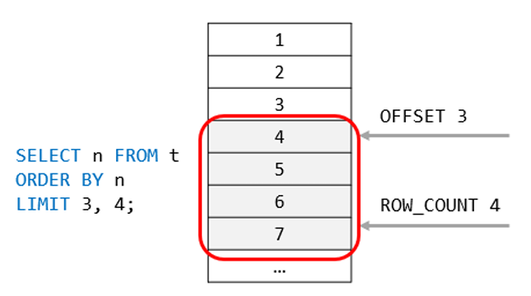

When you use the LIMIT clause with one argument (e.g.: LIMIT 5), MySQL will use this argument to determine the maximum number of rows (here first five rows) to return from the first row of the result set.
Therefore, these two clauses are equivalent:

LIMIT row_count;
And
LIMIT 0, row_count;

Example:

SELECT customerNumber, customerName, creditLimit
FROM customers
ORDER BY creditLimit DESC
LIMIT 5;

- Find Max salary of the employees

SELECT salary as max_salary
FROM employees
ORDER BY salary desc
LIMIT 1;

MYSQL Subqueries:
A MySQL subquery is called an inner query while the query that contains the subquery is called an outer
query. A subquery can be used anywhere that expression is used and must be closed in parentheses.
• In MySQL, a subquery is also called an INNER QUERY or INNER SELECT.
• In MySQL, the main query that contains the subquery is also called the OUTER QUERY or OUTER
SELECT.
The inner select query is usually used to determine the results of the outer select query.

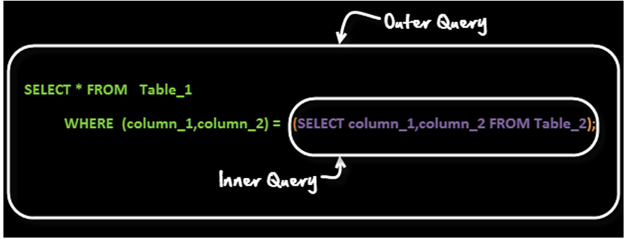

You can use a query like
SELECT category_name
FROM categories
WHERE category_id =( SELECT MIN(category_id) from movies);

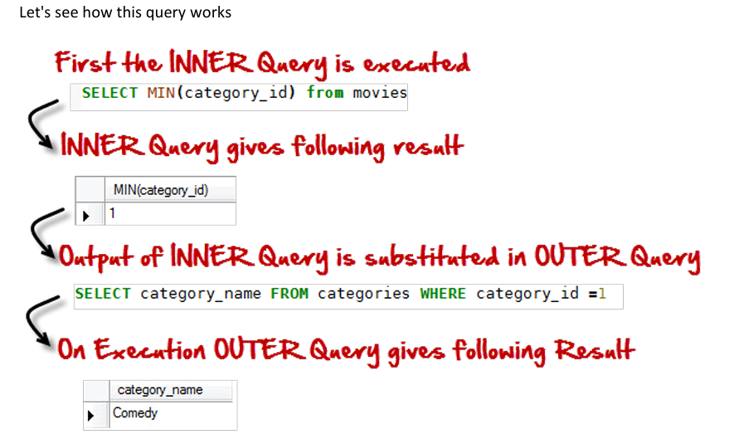

The above is a form of Row Sub-Query. In such sub-queries the , inner query can give only ONE result.
The permissible operators when work with row subqueries are [=, >, =, <=, ,!=, ]
[Sources: https://www.guru99.com/sub-queries.html]
Subqueries: Guidelines
There are some guidelines to consider when using subqueries:
- A subquery must be enclosed in parentheses.
- Use single-row operators with single-row subqueries, and use multiple-row operators with multiple row subqueries.
- If a subquery (inner query) returns a null value to the outer query, the outer query will not return any rows when using certain comparison operators in a WHERE clause.
MySQL Subquery Example:
• Using a subquery, list the name of the employees, paid more than 'Alexander' from emp_details of the hr_schema database.

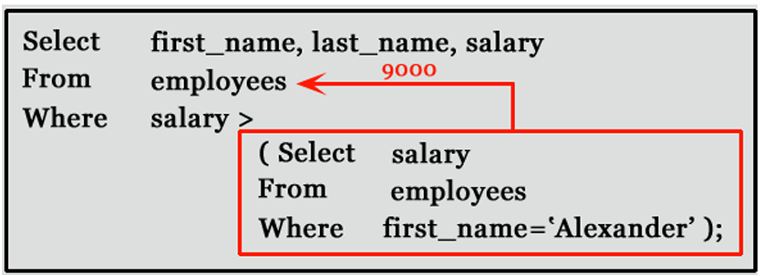
• Suppose you want to find the employee id, first_name, last_name, and salaries for employees whose salary is higher than the average salary throughout the company.
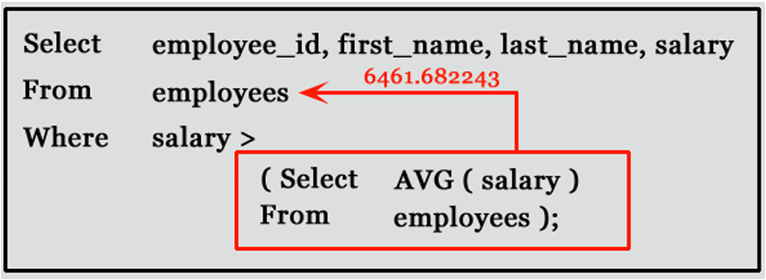
For a more detailed explanation: https://youtu.be/hBF5PO1fD0Q

- Find the department names situated in Seattle

SELECT department_name
FROM departments
WHERE location_id = ( SELECT location_id
FROM locations
WHERE city = 'Seattle') ;
- Find the employees associated with departments from Seattle

SELECT first_name,department_id
FROM employees
WHERE department_id = (SELECT department_id
FROM departments
WHERE location_id = ( SELECT location_id
FROM locations
WHERE city = 'Seattle') );

Observe the output.

SELECT first_name,department_id FROM employees
WHERE department_id IN (SELECT department_id
FROM departments
WHERE location_id = ( SELECT location_id FROM locations WHERE city = 'Seattle')
);

